
School Medical Management System

Class Code: SE1851
Group Code: 3

Ho Chi Minh, June 2025

Record of change

*A - Added M - Modified D - Deleted
Effective Date | Changed Items | A*  M, D | Change Description | New Version
02/12/2025 | Initial | A | Add project overview

SIGNATURE PAGE

LEADER: Võ Văn Cường SE183671 Back End

TEAM MEMBER: Hà Huy Hoàng SE180557 Front End
Nguyễn Gia Phú SE183613 Front End
Nguyễn Văn Khoa SE183702 Back End
Huỳnh Trung Chính SE183685 Back End

TABLE OF CONTENTS
1 Introduction 5
1.1 Purpose 5
1.2 Definitions, Acronyms 5
1.3 References 5
2 Overall Description 6
2.1 Product Perspective 6
2.2 Business Process 6
2.3 User classes and characteristics 6
3 FUNCTIONAL Requirements 7
3.1 Use Case Diagram 7
3.2 Use Case Specifications 7
3.2.1. < Conduct Health Check > 7
3.2.2. < Conduct Vaccination > 8
3.2.3. < Medical event at school > 8
3.3 State Diagrams 8
3.4 Data flow Diagrams 8
3.5 Logical Data Model 8
4 NON-FUNCTIONAL Requirements 9
4.1 Usability 9
4.2 Reliability 9
4.3 Performance 10
4.4 Reusability 10
4.5 Scalability 10
5 Supporting Information 11

Introduction
[The introduction of the Software Requirements Specification (SRS) provides an overview of the entire SRS. It includes the purpose, scope, definitions, acronyms, abbreviations, references, and overview of the SRS.]
[Note: The SRS document captures the complete software requirements for the system, or a portion of the system. Following is a typical SRS outline for a project using only traditional, natural-language style requirements—with no use-case modeling. It captures all requirements in a single document, with applicable sections inserted from the Supplementary Specifications (which would no longer be needed). For a template of an SRS using use-case modeling, which consists of a package containing Use Cases of the use-case model and applicable Supplementary Specifications and other supporting information, see rup_srsuc.dot.]
[Many different arrangements of an SRS are possible. Refer to [IEEE830-1998] for further elaboration of these explanations, as well as other options for SRS organization.]

Purpose
- The purpose of this Software Requirements Specification (SRS) is to define the functionalities, constraints, and requirements of the School Medical Management System (SMMS). This document serves as a guide for developers, testers, and stakeholders to ensure a shared understanding of the system's goals and capabilities. It captures both functional and non-functional requirements to support the development and maintenance of a centralized platform that manages medical records and health-related activities within a school environment.

Definitions, Acronyms
Term / Acronym Definition
MTBF – Mean Time Between Failures
MTTR – Mean Time To Repair
KLOC - Lines of code.

References
- IEEE 830-1998 – IEEE Recommended Practice for Software Requirements Specifications
- School Health Policy Manual – Ministry of Education (2022)
- Project Proposal Document – SMMS Team, May 2025
- FPT University SE Course Materials – Software Engineering Spring 2025

Overall Description

Product Perspective
The School Medical Management System (SMMS) is a new web-based platform designed to replace the traditional paper-based process used to manage student health records in schools. While it operates as a standalone system, it can also be integrated with existing student information systems to enable seamless data synchronization.
The main objectives of the system are:
- To centrally manage student health records on an individual basis.
- To schedule and track the history of periodic health checkups.
- To record and monitor vaccine immunization history, including types of vaccines administered and dates.
- To manage medical supplies and equipment used in the school’s health office.
- To allow parents or guardians to submit medications to be administered to their children at school, with proper tracking and nurse confirmation.
- To log and report medical incidents occurring on campus, such as fainting, injuries, or sudden illnesses

Business Process

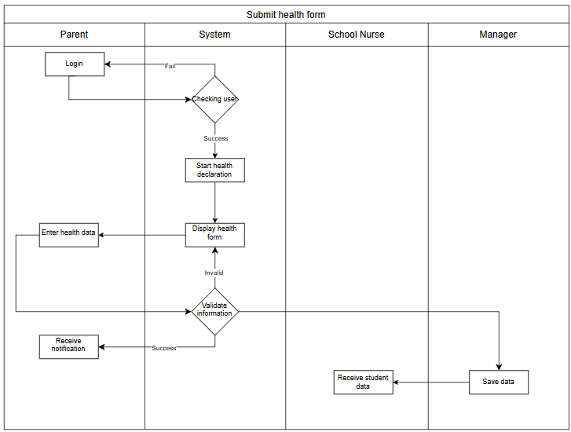
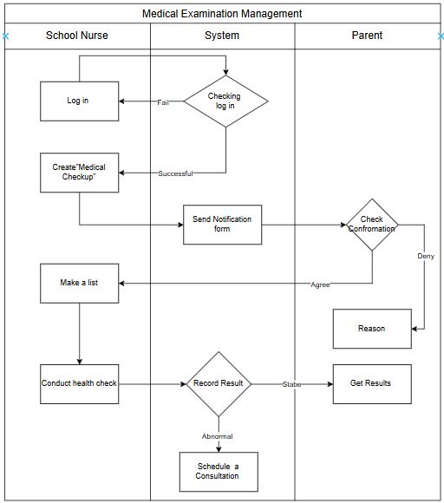
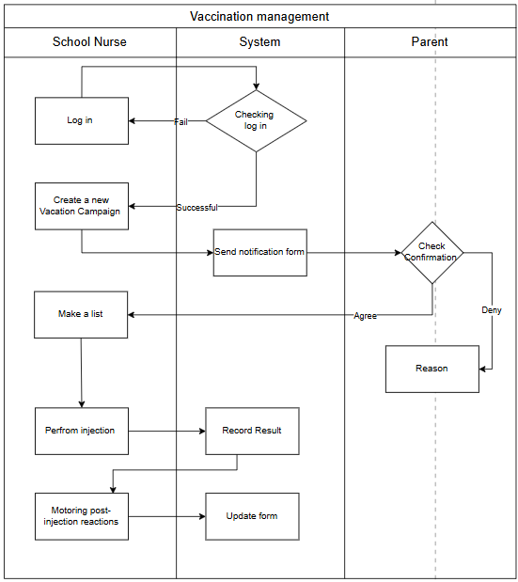

User classes
Description
- Manager: Has administrative privileges to approve health check schedules, review reports, and oversee the overall operation of the system.
- Nurse: The main user of the system. Responsible for recording student health data, scheduling checkups, tracking vaccinations, managing medical incidents, and handling medications.
- Parent: Can submit medications for their child and view basic health-related information and reports, if access is granted.

FUNCTIONAL Requirements

Use Case Diagram

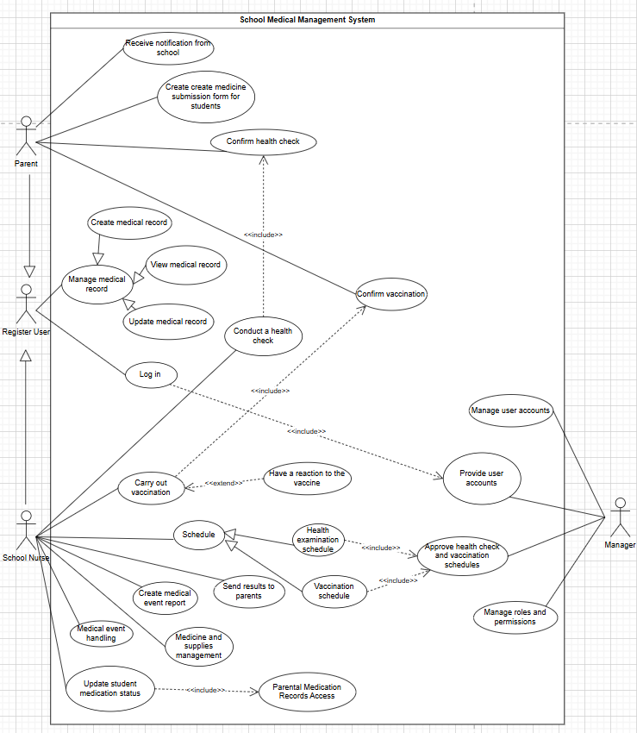

Use Case Specifications
3.2.1 Conduct Health Check
USE CASE SPECIFICATION

Use-case No. | UC-01 | Use-case Version |  | 1.0
Use-case Name | Conduct a health check
Author | Huy Hoàng
Date | June 19, 2025 | Priority | High
Primary Actor: School nurse
Secondary Actor:Parent
Description:
The school nurse create a medical examination and send consent form to the parents. Then the school nurse will take the students who have the consent of the parents to make a list and conduct the examination
Triggers:
The school nurse indicates that he/she would like to create a health check on the system.
Preconditions:
PRE-1. The school nurse's identity has been authenticated
PRE-2. Parental consent form must be received
Post Conditions:
POST-1. The health check session status is marked as "Completed" in the system.
POST-2. Health check results are saved in the student’s medical record in the database.
Main Success Scenario:
- Conduct a health check
1.School nurse access Health check page and click “create health check’
2. Nurse fill in the session info and submits.
3. System saves the session as "Pending Approval" and sends a notification to the Parent requesting approval.
4. Parent opens the form and chooses to "Agree" or "Decline" on website
5. System records the parent's decision and send it to school nurse.
6. The nurse views the consent status and conducts the examination only for approved students
7. The nurse submits health check results for each approved student.
8. The system saves all results and marks the session as "Completed"
Alternative Scenario:
1.4 Parent opens the form and chooses to "Agree" or "Decline" on Gmail.
1. System sends a consent request email to the parent's gmail inbox.
2. Parent opens the Gmail email and clicks on one of the response buttons "Agree" or ''Decline" in the email. 3. The email system sends the selected response to the health check system via a preconfigured endpoint
4. The system records the parent's decision and send it to school nurse.
5. The nurse views the consent status and conducts the examination only for approved students
6. The nurse submits health check results for each approved student.
7. The system saves all results and marks the session as "Completed"
Exceptions:
1.2.E1 Invalid test creation information
1. The system validates the input.
2. If data is missing or invalid, the system throws an error message: “Missing or invalid data. Please complete all required fields.”
3. The system does not allow submission until the issue is corrected.
Frequency of Use:
This use case is expected to be used once every school term (or monthly, depending on health check schedules).
Business Rules:
-A student must not be examined without parental consent.
-Consent forms expire after 72 hours if not responded to.
-Only authenticated school nurses can create or manage health check sessions
Other Information:
-Notifications to parents are sent via both app and email.
-The system uses role-based access control to restrict features
Assumptions:
-All parents have valid email addresses registered in the system.
-The school nurse has already logged in and has appropriate permissions.
-The internet connection is stable during the submission and notification process.

3.2.2 Conduct Vaccination
USE CASE SPECIFICATION

Use-case No. | UC-02 | Use-case Version |  | <2.0>
Use-case Name | UC-02: Conduct Vaccination
Author | Võ Văn Cường
Date | 19/06/2025 | Priority | High
Primary Actor: School Nurse
Secondary Actor: Parent
Description: The medical staff will fill in the vaccination information then the medical staff will send the blank vaccination form to the parents and make a list of students with the parents' consent after the vaccination process for the students, after the vaccination is completed, monitor the students' reactions after the vaccination and fill in the form to send notification to the parents.
Triggers: The school nurse indicates that he/she would like to create a vaccination on the system
Preconditions:
PRE-1. The school nurse's identity has been authenticated
PRE-2. Parental consent form must be received
PRE-3. List of vaccines and vaccine lots already in the system
Post Conditions:
POST-1. The vaccination page session status is marked as "Completed" in the system.
POST-2. vaccination check results are saved in the student’s medical record in the database.
Main Success Scenario:
1.0 Conduct a Vaccination
1.School nurse access vaccination page and click “create vaccination’
2. Nurse fill in the session info and submits “form vaccination’ for parent
3. System saves the session as "Pending Approval" and sends a notification to the Parent requesting approval.
4. Parent opens the form and chooses to "Agree" or "Decline" on website
5. System records the parent's decision and send it to school nurse.
6. The nurse views the consent status and conducts the examination only for approved students
7. If the student has a reaction after the injection, follow-up will be conducted.
8. The nurse submits vaccination results for each approved student.
9. The system saves all results and marks the session as "Completed".
Alternative Scenario:
1.4 Parent opens the form and chooses to "Agree" or "Decline" on Gmail.
1. System sends a consent request email to the parent's gmail inbox.
2. Parent opens the Gmail email and clicks on one of the response buttons "Agree" or ''Decline" in the email.
3. The email system sends the selected response to the vaccination system
4. The system records the parent's decision and send it to school nurse.
5. The nurse views the consent status and conducts the examination only for approved students
6. If the student has a reaction after the injection, follow-up will be conducted.
7. The nurse submits vaccination results for each approved student.
8. The system saves all results and marks the session as "Completed".
Exceptions:
1.2.E1 Invalid test creation information
1. The system validates the input.
2. If data is missing or invalid, the system throws an error message:
“Missing or invalid data. Please complete all required fields.”
3. The system does not allow submission until the issue is corrected.
Frequency of Use:
This use case is expected to be used once every school term (or monthly, depending on vacations check schedules).
Business Rules:
-A student must not be examined without parental consent.
-Consent forms expire after 72 hours if not responded to.
-Only authenticated school nurses can create or manage vaccination check sessions.
Other Information:
-Notifications to parents are sent via both app and email.
-The system uses role-based access control to restrict features
Assumptions:
-All parents have valid email addresses registered in the system.
-The school nurse has already logged in and has appropriate permissions.
-The internet connection is stable during the submission and notification process.

3.2.3 Medical event at school
USE CASE SPECIFICATION

Use-case No. | UC-03 | Use-case Version |  | <3.0>
Use-case Name | UC-03: Medical event at school
Author | Võ Văn Cường
Date | 29/06/2025 | Priority | High
Primary Actor: School Nurse
Secondary Actor: Parent
Description: After handling a medical event (e.g., fever, accident, outbreak), the school nurse creates a Medical Event Report on the system. This report is then sent to the parents to inform them of the student’s condition. The process includes monitoring the student, entering observations, and notifying parents via the system.
Triggers: The school nurse indicates that he/she would like to create medical event report on the system
Preconditions:
PRE-1. The school nurse's identity has been authenticated
PRE-2. The list of medical supplies lots already in the system
Post Conditions:
POST-1. The event page session status is marked as "Completed" in the system.
POST-2. Event handling results are saved in the student’s medical record in the database.
Main Success Scenario:
1.0 Conduct a Medical Event
1. The school nurse accesses the event page and clicks “Create Medical Event Report.”
2. The nurse enters event details, including event type (e.g., fever, accident, outbreak, etc.).
3. The nurse monitors the student's condition and takes appropriate actions based on the type of medical event.
4. A notification is sent to the parent.
5. The system logs and updates the student's medical record.
6. The system saves all results and marks the session as "Completed".
Alternative Scenario:
1.4 Parent opens the form on Gmail.
1. System sends a consent request email to the parent's gmail inbox.
2. The nurse enters event details, including event type (e.g., fever, accident, outbreak, etc.).
3. The nurse monitors the student's condition and takes appropriate actions based on the type of medical event.
4. A notification is sent to the parent.
5. The system logs and updates the student's medical record.
6. The system saves all results and marks the session as "Completed".
Exceptions:
1.2.E1 Invalid test creation information
1. The system validates the input.
2. If data is missing or invalid, the system throws an error message:
“Missing or invalid data. Please complete all required fields.”
3. The system does not allow submission until the issue is corrected.
Frequency of Use:
This use case is expected to be used whenever a student experiences a medical event at school (e.g., fever, injury, outbreak).
Business Rules:
- The medical event report must be sent to the student’s parent or guardian after the event has been handled.
-Only authenticated school nurses can create or manage Medical Event Report sessions.
Other Information:
-Notifications to parents are sent via both app and email.
-The system uses role-based access control to restrict features
Assumptions:
-All parents have valid email addresses registered in the system.
-The school nurse has already logged in and has appropriate permissions.
-The internet connection is stable during the submission and notification process.

State Diagrams
3.3.1 State Diagrams For Vaccination

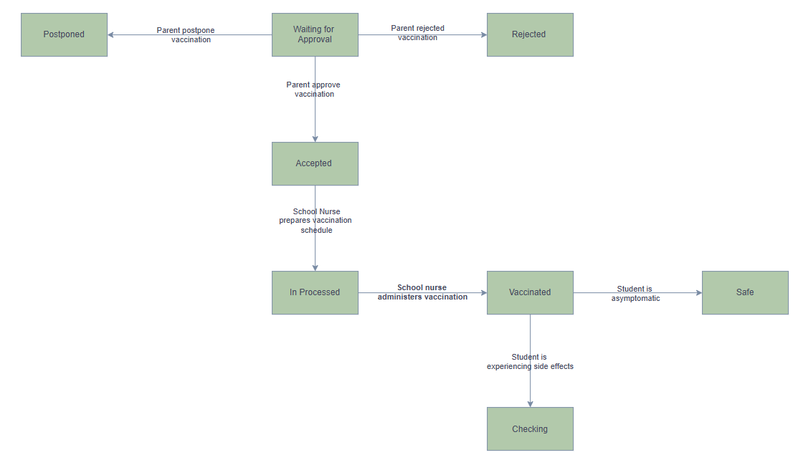
3.3.2 State Diagram For Medical Submission
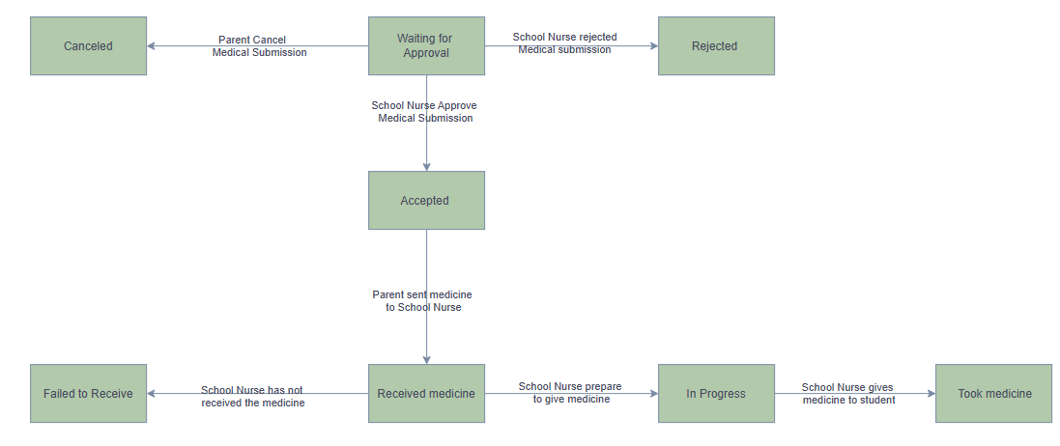

3.3.3 State Diagram For Regular Health-Check
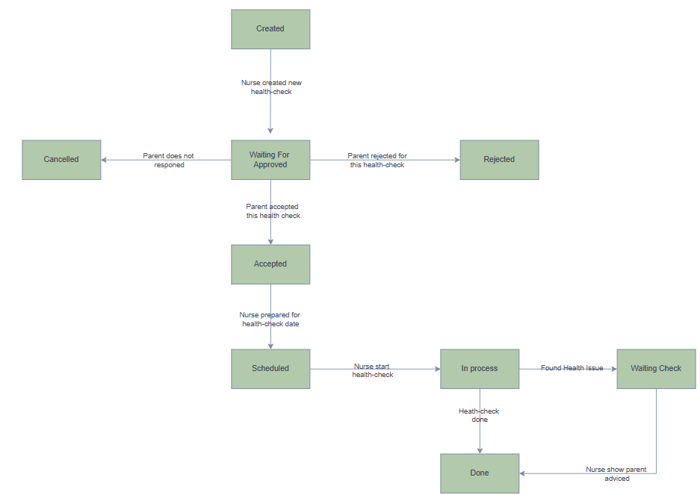

Data flow Diagrams
    - Data Flow For Health Check

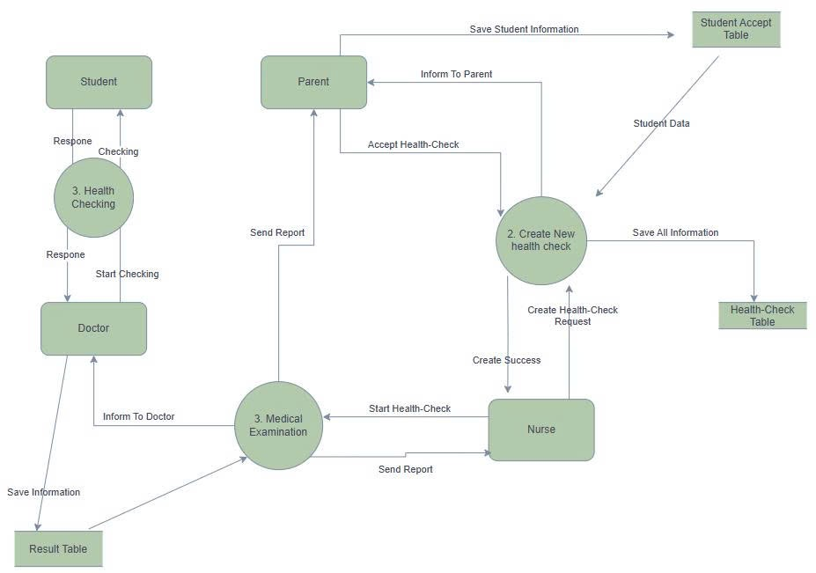

    - Data Flow For Vaccination

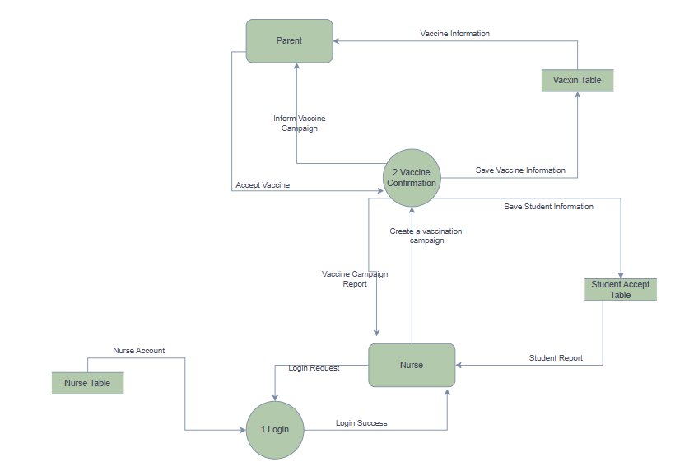

    - Data Flow For medical submission
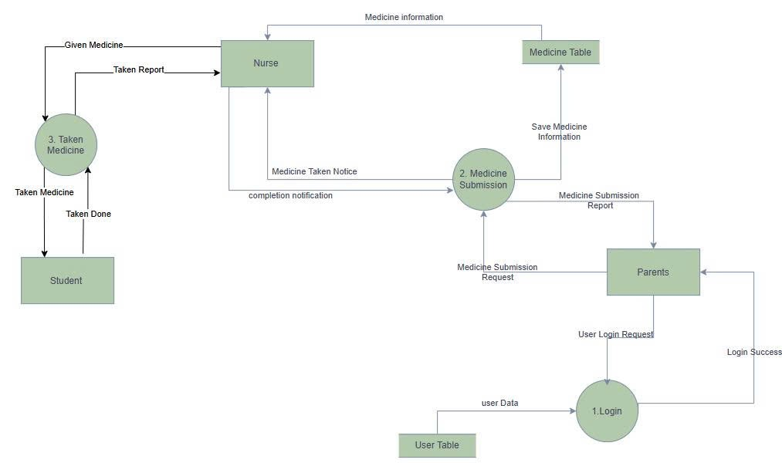

Logical Data Mode

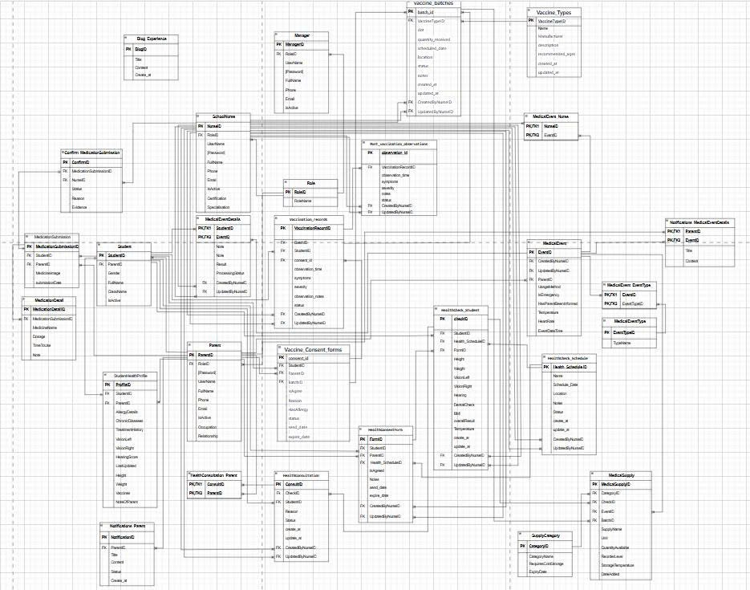

NON-FUNCTIONAL Requirements

Usability
- The interface is designed to be intuitive and user-friendly for all roles including parents, school nurses, managers, and students.
- New users (parents or school medical staff) should be able to learn the basic system operations within 20 minutes.
- The interface is compatible with major browsers (Chrome, Firefox, Edge) and various devices (PC, tablets).
- The design follows standard Microsoft GUI guidelines to ensure consistency and usability.

Reliability
- The system guarantees an availability of at least 99.7% during working hours (06:00–21:00, weekdays).
- Mean Time Between Failures (MTBF) is at least 3 months.
- Mean Time To Repair (MTTR) must not exceed 2 hours for critical failures.
- The system must not lose any medical records or logs during operations such as form submission, vaccination tracking, or report generation.
- The rate of critical bugs should not exceed 1 bug per 10,000 lines of code (KLOC).

Performance
- The system supports at least 100 concurrent users from different roles without noticeable lag.
- The average response time for retrieving reports, records, or health information must be less than 1.5 seconds per request.

Reusability
- Core modules such as notification forms, health check forms, and report generation components are designed for reuse across different functionalities (e.g., vaccination, vision screening, general health checks).
- UI components like "Notification Form", "Student List Table", and "Parent Result Notification" are reusable across various screens.

Scalability
- The system can be easily scaled to support multiple schools within the same city without changes to the core software architecture.
- The database structure supports adding more users, roles, and permissions without impacting performance

Supporting Information
[The supporting information makes the SRS easier to use. It includes:
Index
Appendices
These may include use-case storyboards or user-interface prototypes. When appendices are included, the SRS should explicitly state whether or not the appendices are to be considered part of the requirements.]

